

**Tribhuvan University**

**Faculty of Humanities and Social Sciences**

Cloud Computing

A LAB REPORT

Submitted to

Department of Computer Application

Shahid Smarak College

*In partial fulfillment of the requirements for the Bachelors in Computer Application*

**Submitted by: -**

Amir Maharjan

**Instructor**

Hari Lal Chalise

**External Examiner**

**Table of Contents**

**Question 1:** Write down step by step instruction to install Virtual Box with different flavors of Linux or windows OS. 1

**Question 2:** Take Snapshot of each VM OS and restore it. 7

**Question 3:** Register an” amazon educate” account with college email address. 9

**Question 4:** Upload any file to amazon s3. 12

**Question 5:** Amazon Instance EC2 16

**Question 6:** Creating a Virtual Private Cloud (VPC) 21

# Question 1

Write down step by step instruction to install Virtual Box with different flavors of Linux or windows OS.

**Objective:** Tohelp install Oracle VM VirtualBox and set up various operating systems (Linux or Windows) as virtual machines.

**Steps 1:** Download virtual box from <https://www.virtualbox.org/wiki/Downloads>.

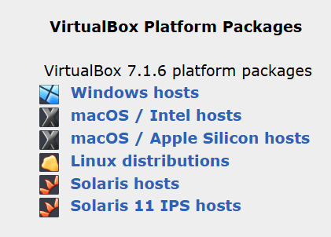

**Steps 2:** Open the downloaded file.

**Step 2.1:** Initial interface is shown below. Click Next Button.

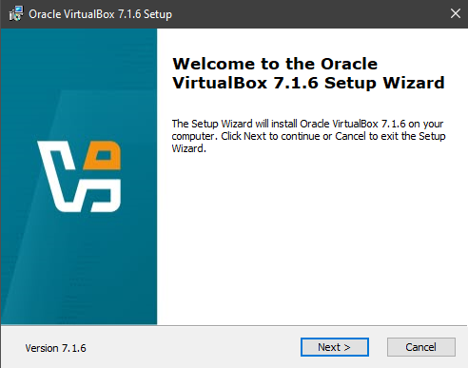

**Step 2.2:** After clicking the next button, this interface will be shown, check I accept and click next.

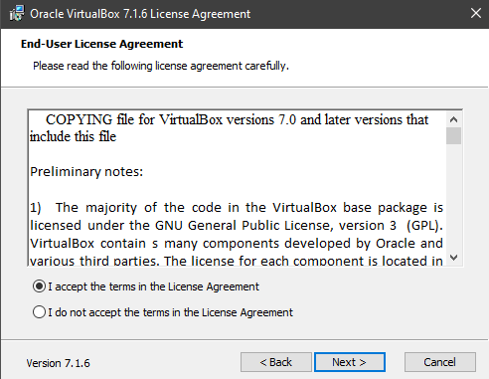

**Step 2.3:** Now select a location and click next.

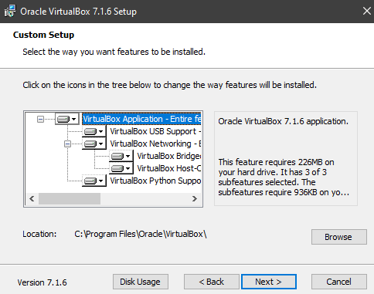

**Step 2.4:** Select the way you want features to be installed.

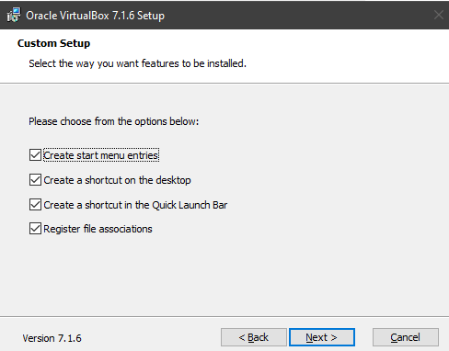

**Step 2.5:** Ready to Install, click install.

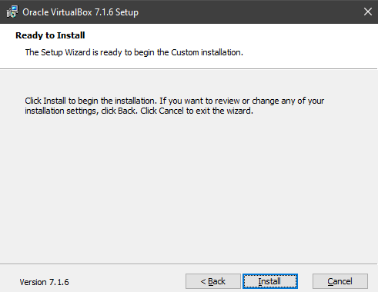

**Step 2.6:** Wait for installation to be completed.

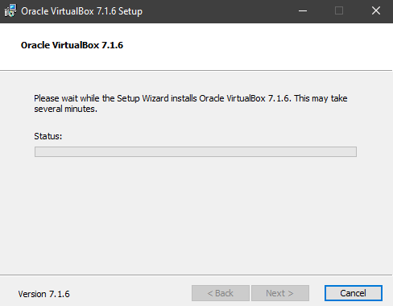

**Step 2.6:** Installation is completed. Click Finish.

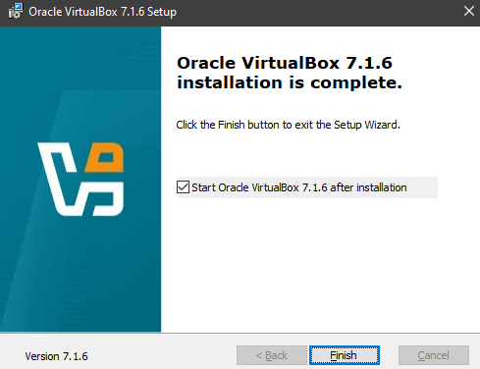

**Step 3:** Download the OS disc file that you want to install in the virtual box. We will install [linuxmint](https://www.linuxmint.com/edition.php?id=319).

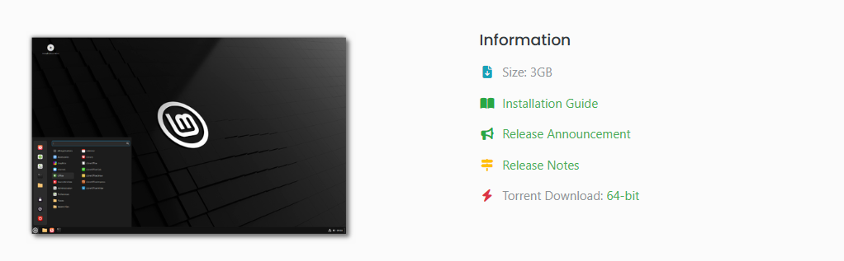

**Step 4:** While we wait for download to complete, lets fire up the virtual box. The initial interface is shown below.

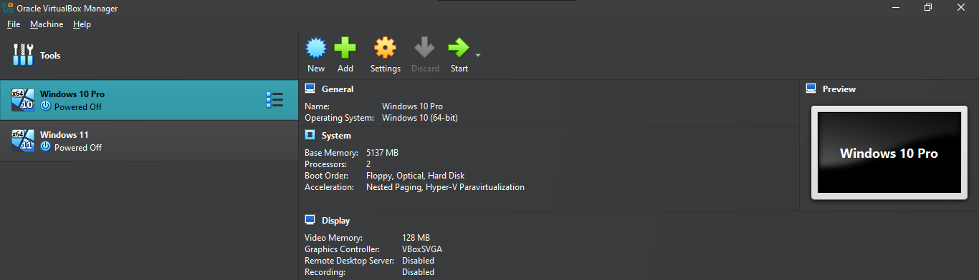

**Step 5:** Click on the New button in the top bar, a popup will be shown.

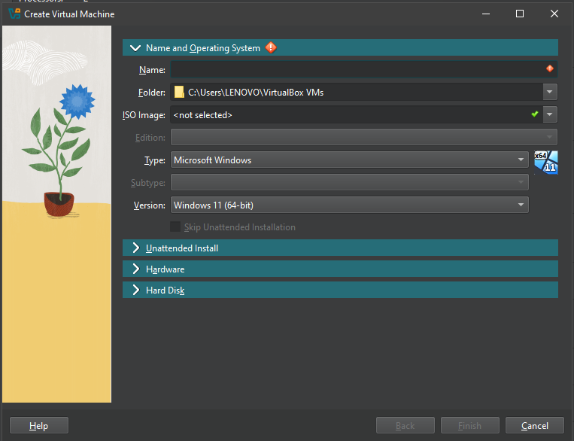

**Step 6:** Fill out the details and select the downloaded iso disc file in iso image field and click finish. The added OS will be shown in the left-hand side of the screen.

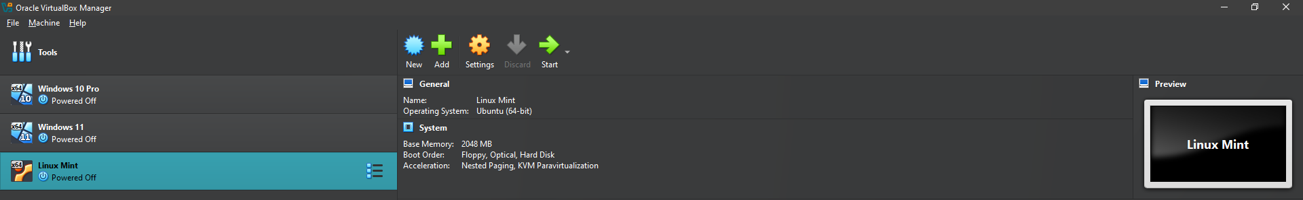

**Step 7:** Clickthe start button in the top bar and the linux mint OS should fire up.   
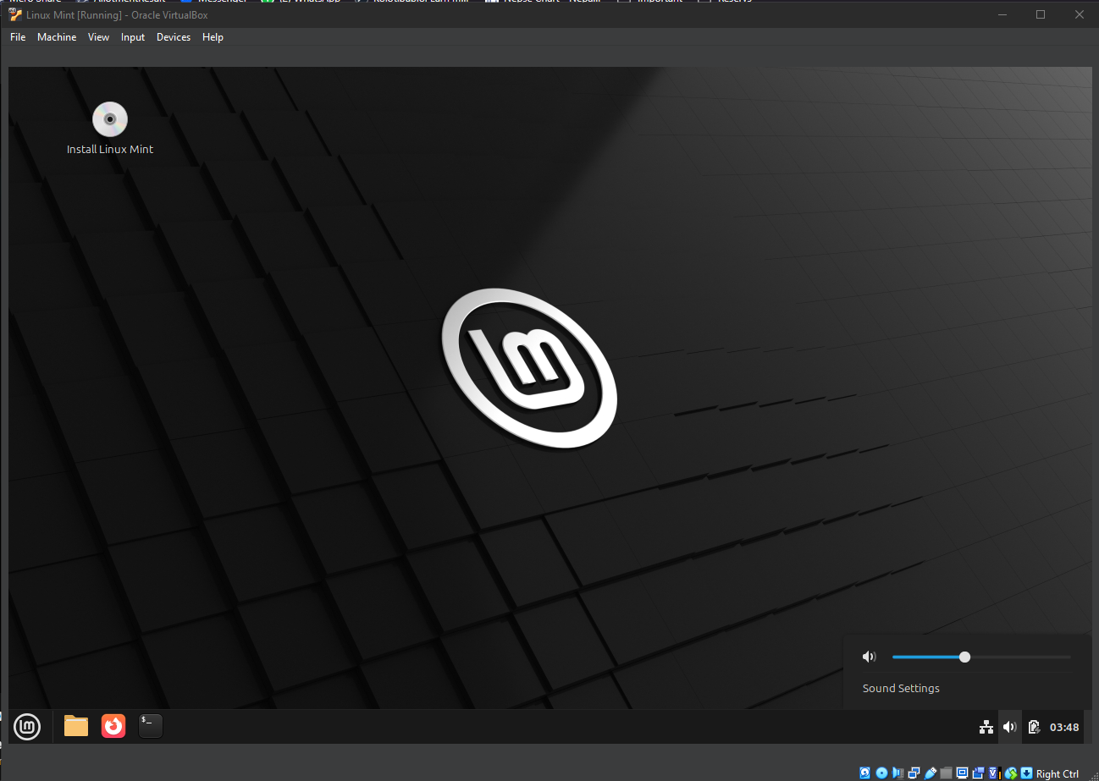

# Question 2

Take Snapshot of each VM OS and restore it.

**Objective:** Tohelp take snapshots of each virtual machine (VM) operating system and restore them using Oracle VM VirtualBox.

**Step 1:** In themachine tab, you will see take a snapshot option, click on it.

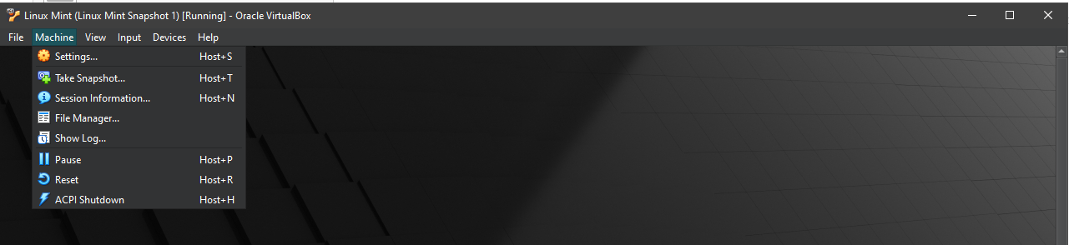

**Step 2:** A new popup will show, fill out the details and click ok.

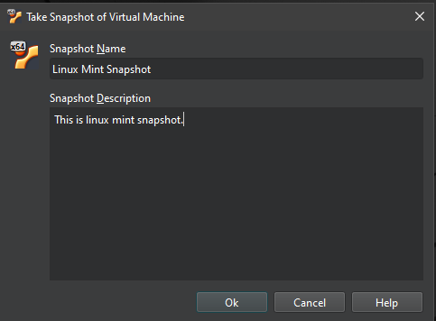

**Step 3:** When closing the OS, you will see a new option “Restore current snapshot Linux Mint Snapshot”. Check it and click ok.

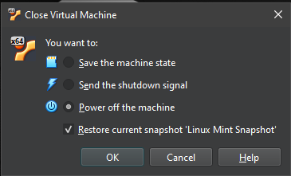

**Step 4:** You will see the name of the snapshot in the left-hand side of the screen

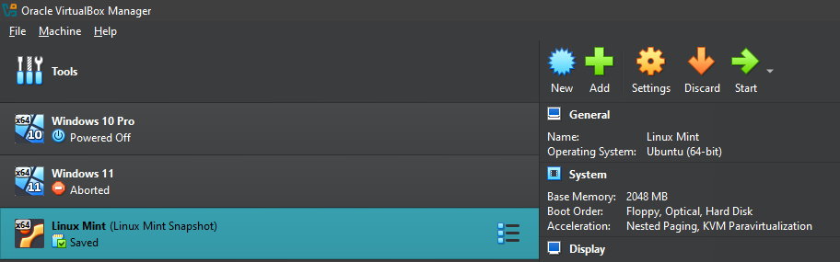

# Question 3

Register an” amazon educate” account with college email address.

**Objective:** Tohelp walk through the process of registering an **Amazon Educate** account using your college email address

**Step 1:** Go to [aws.amazon.com/education/awseducate/](https://aws.amazon.com/education/awseducate/) and click register now.

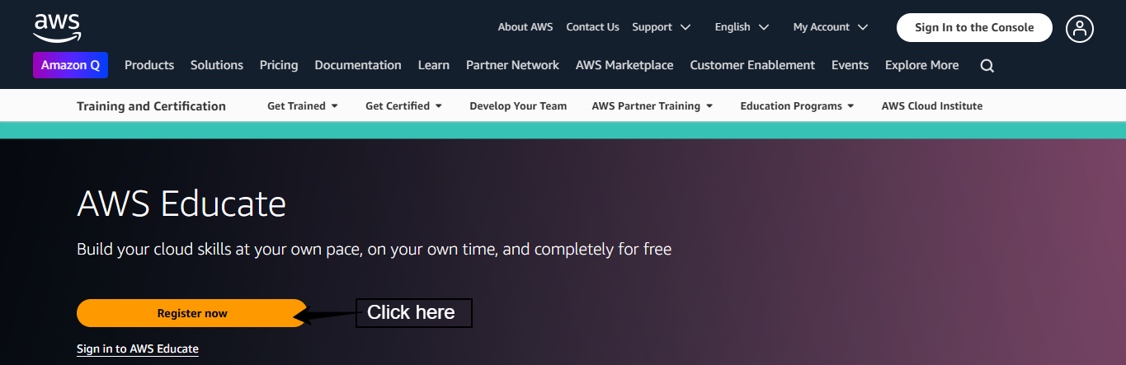

**Step 2:** Fill out the form and click create account.

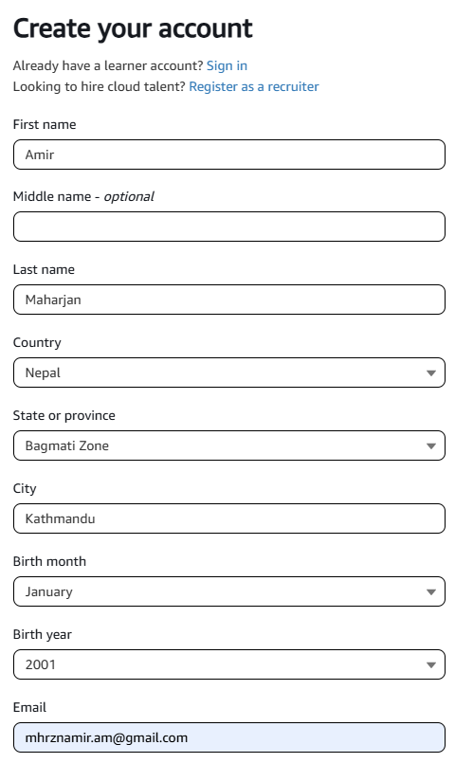

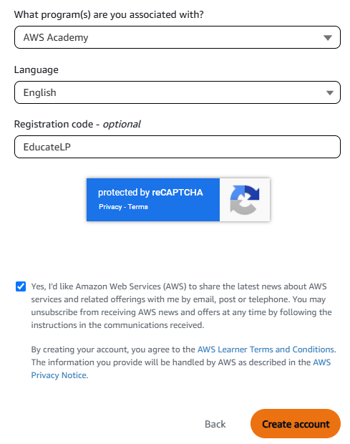

**Step 3:** Check email to verify your registration and shortly after another email will be sent to you to set a password.

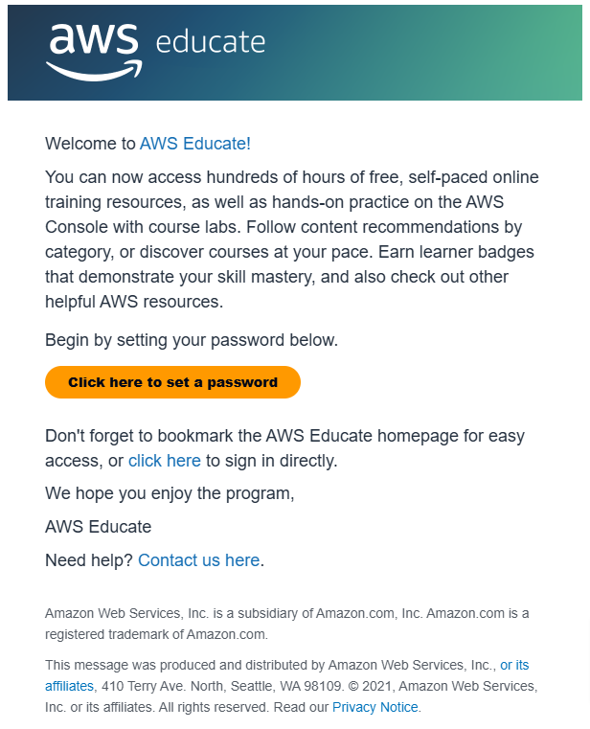

Step 4: After clicking on “Click here to set a password”, you will be redirected to a popup like below.

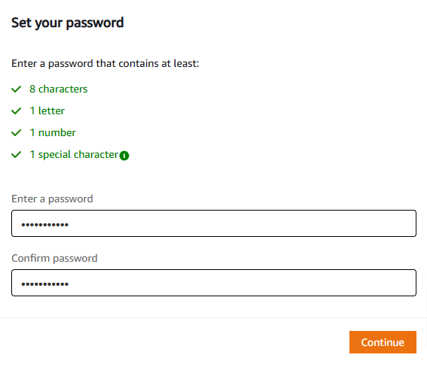

**Step 5:** After clicking continue in step 4, you will be redirected to a page below:

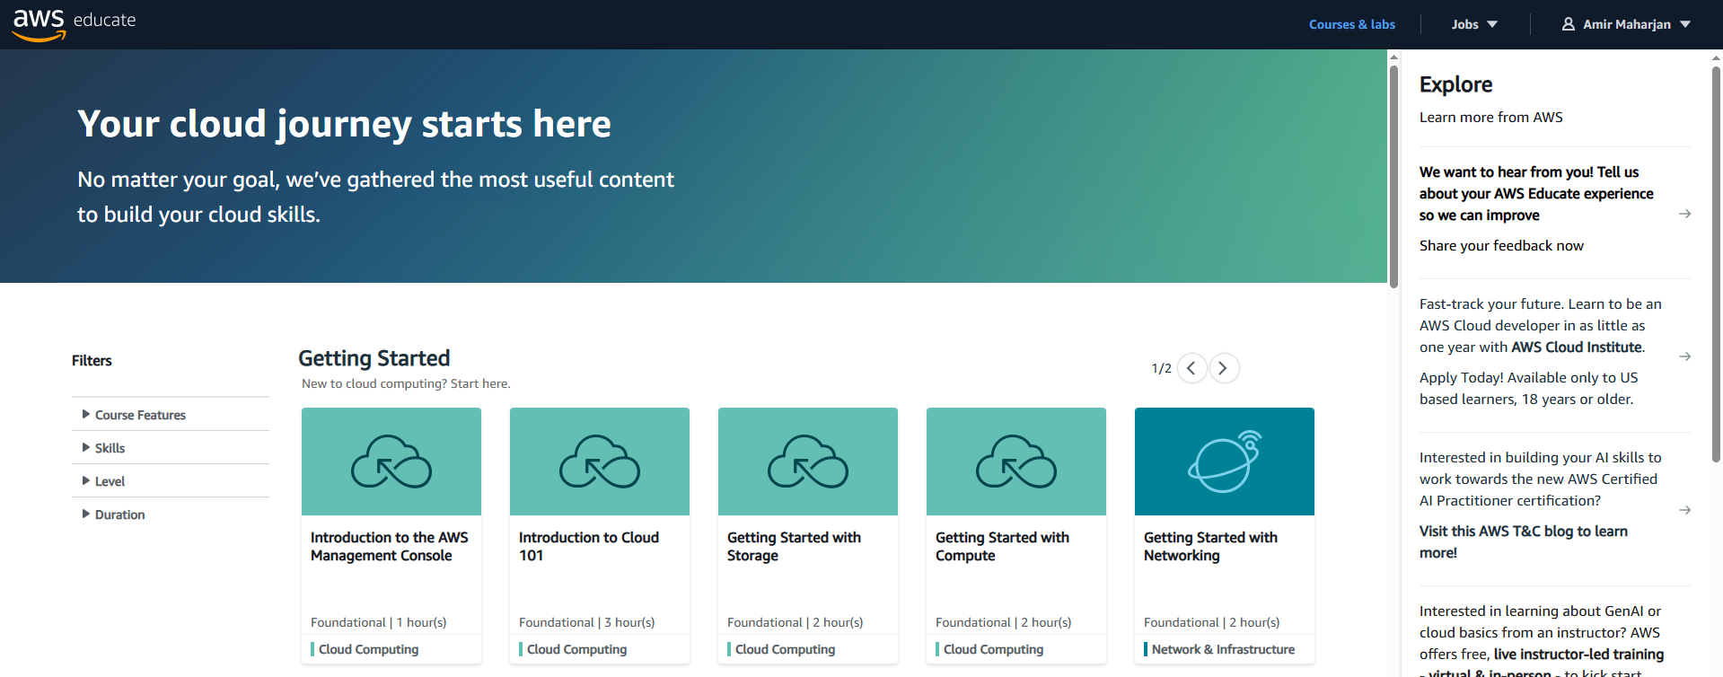

# Question 4

Upload any file to amazon s3.

**Objective:** to through the process of uploading a file to **Amazon S3** (Simple Storage Service).

**Amazon S3** is a scalable object storage service provided by Amazon Web Services (AWS) that allows you to store and retrieve any amount of data at any time.

**Bucket:** A bucket is a container for storing objects (files) in S3. Every object is stored in a bucket and is identified by a unique key (name). You can think of a bucket as a folder in a file system, but it exists at a global level, meaning each bucket name in S3 must be unique across all AWS users.

**Usage:**

* **Store files:** You can store any type of data (images, videos, documents, backups, etc.) in an S3 bucket.
* **Organize:** Buckets help organize your files in a way that they are easy to access and manage.
* **Access control:** You can set permissions on a bucket and its contents to control access, allowing only authorized users to upload or download files.

**Step 1:** Open the amazon console <http://console.aws.amazon.com/>.

**Step 2:** Click on the bar in the left-hand side of the screen



**Step 3:** A sidebar will open, click on all services.

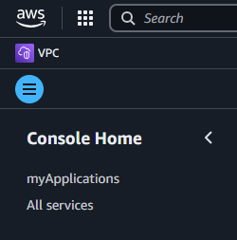

**Step 4:** A full list of services will be shown to you, find and select a service called S3.

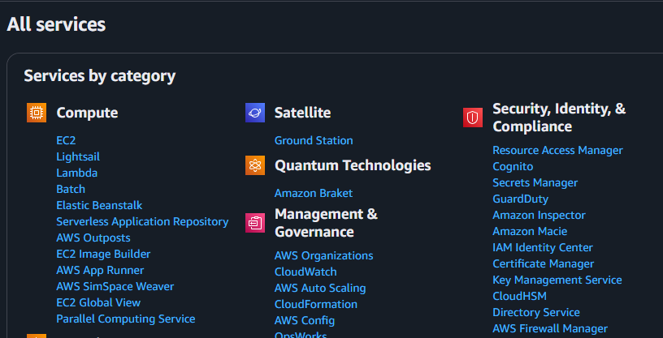

**Step 5:** After select S3, you will be redirected to a new page.

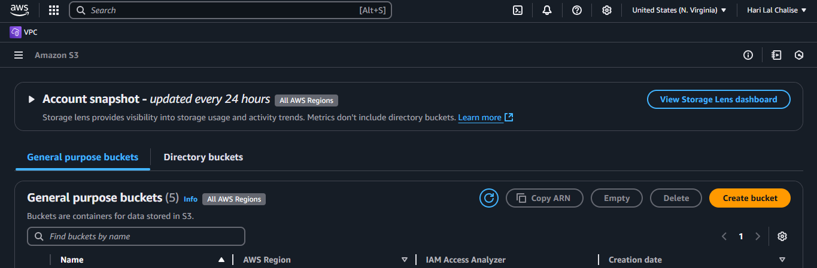

**Step 6:** You will see a “Create Bucket” button click on it and you will be redirected to this page.

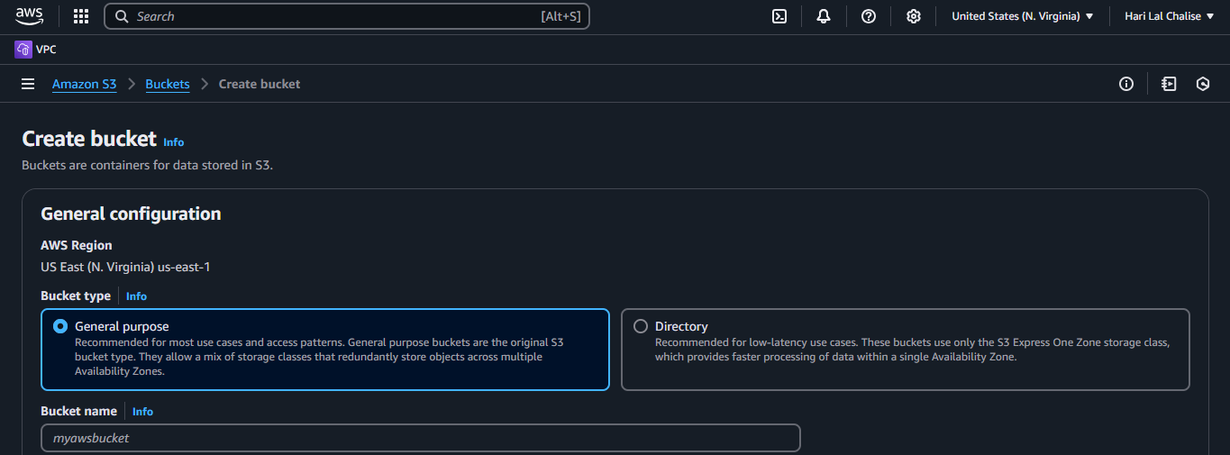

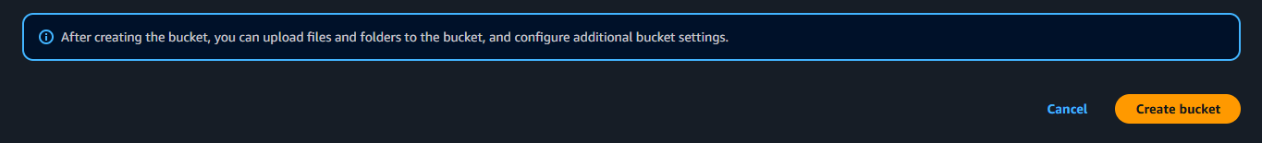

**Step 7:** After creating a bucket, you will see the bucket you created here.

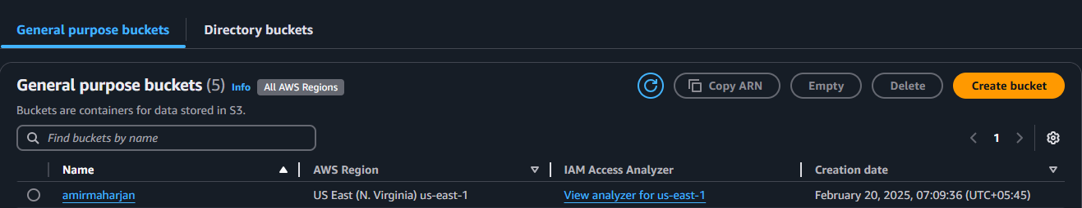

**Step 8:** From the list of buckets, click on the one you just created. You will be redirected here.

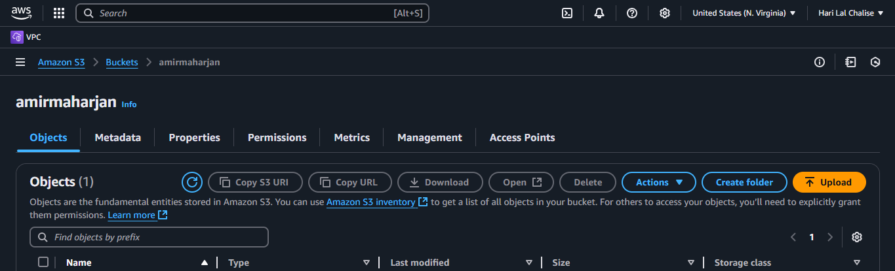

**Step 9:** You will see an “Upload” button. Click on it and you will be redirected here. There are “Add Files” and “Add Folders” buttons that will allow you to upload objects like pdf, images, etc.

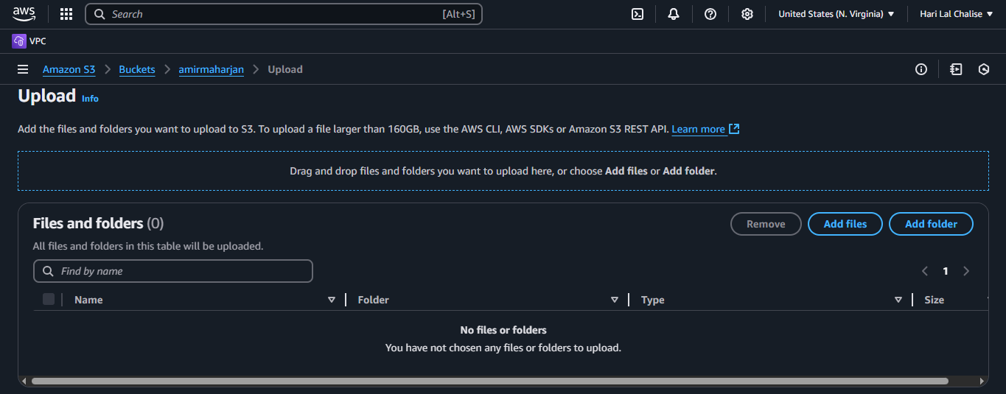



**Step 10:** After uploading your desired files, you will see them here.

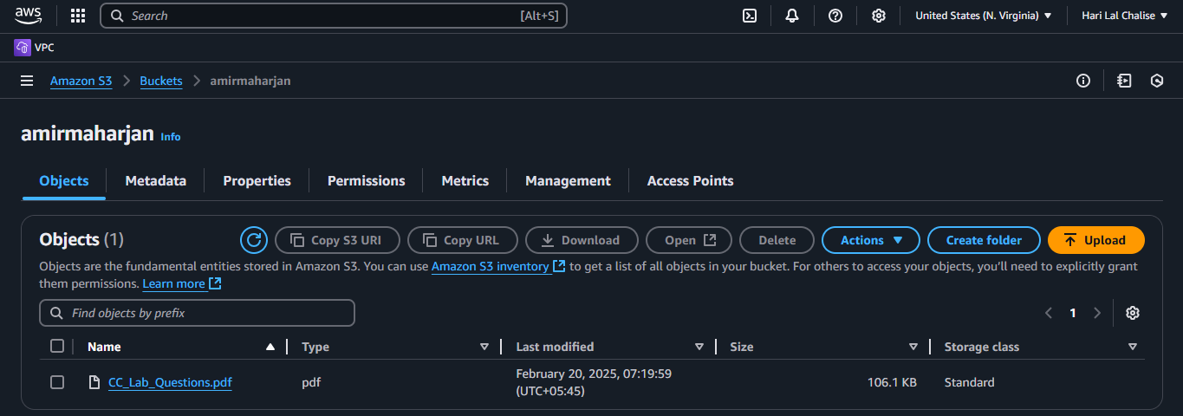

**Step 11:** Click on the object you have uploaded and you will see something like this. Click on the “Object URL” link.

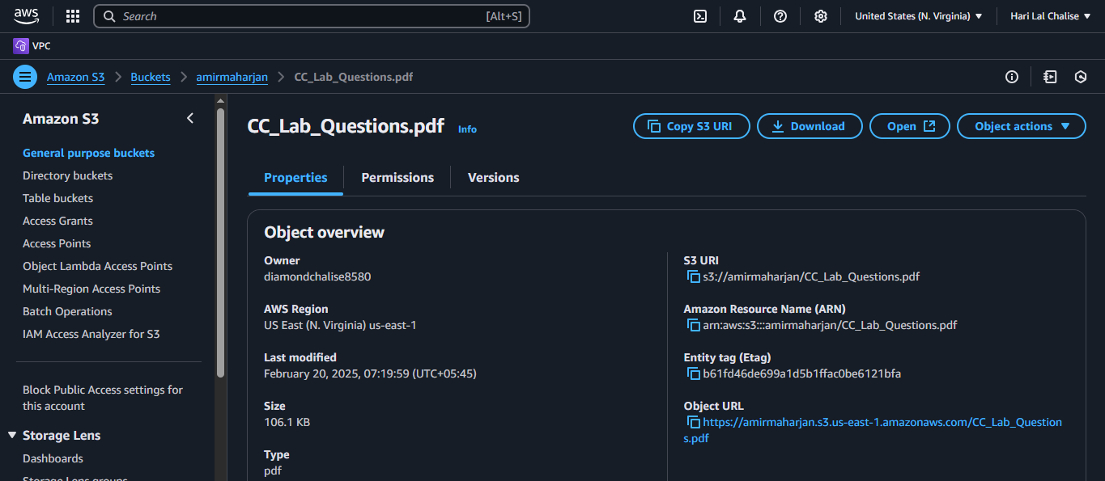

**Step 12:** When you click on the link you will be redirected to contents of your uploaded objects.

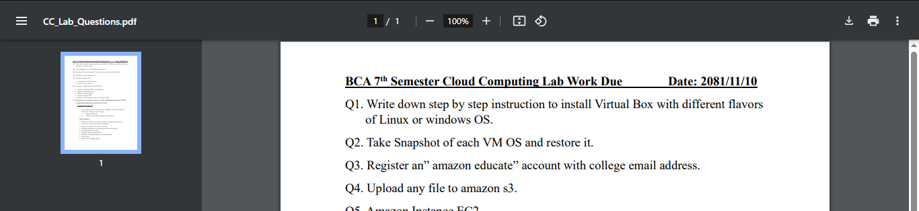

# Question 5

Amazon Instance EC2

1. Launching an EC2 Instance
2. Monitor your instance

**Objective:** to learn how to launch an EC2 instance and monitor it.

**EC2:** a virtual server in Amazon's Elastic Compute Cloud (EC2) scalable compute platform for running applications on the Amazon Web Services (AWS) cloud.

**Usage**

* **Web Hosting**: Host dynamic websites and applications.
* **Data Processing**: Run big data analytics and machine learning models.
* **Application Hosting**: Host microservices and backend applications.

1. **Launching an EC2 Instance**

**Step 1:** Open the amazon console <http://console.aws.amazon.com/>.

**Step 2:** Click on the bar in the left-hand side of the screen



**Step 3:** A sidebar will open, click on all services.



**Step 4:** A full list of services will be shown to you, find and select a service called EC2.

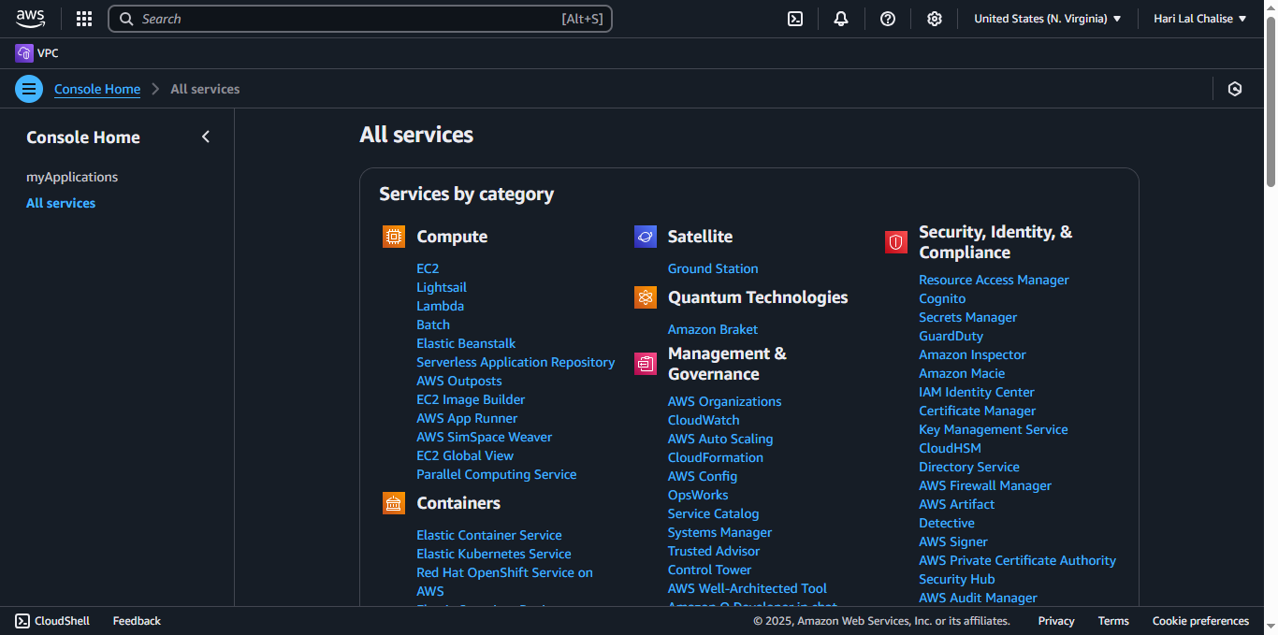

**Step 5:** After click on EC2 service, you will be redirected here.

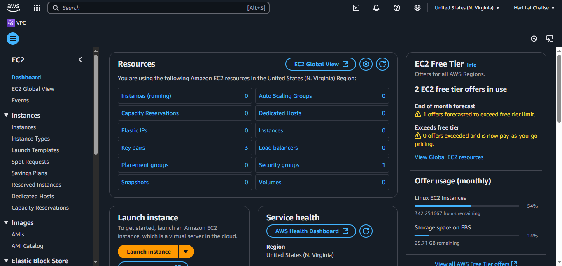

**Step 6:** Fill the necessary details like “Name and tags”, “Instance Types”, “Key pair” and click on “Launch Instance” button. Note: “Instance Types” may charge additional costs depending on the type you choose. As for “Key pair”, if a key pair already exists select that or create a new key pair by clicking on the “create new key pair” button.

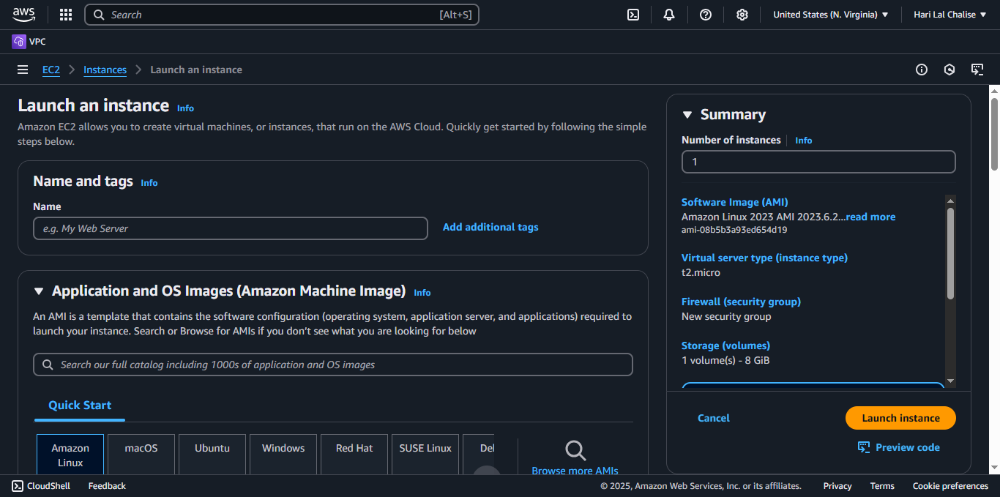

**Step 7:** Launching an instance will take a while. After instance is successfully launched you will see a “View all instances” button, click on it and it will show you the list of all the EC2 instances.

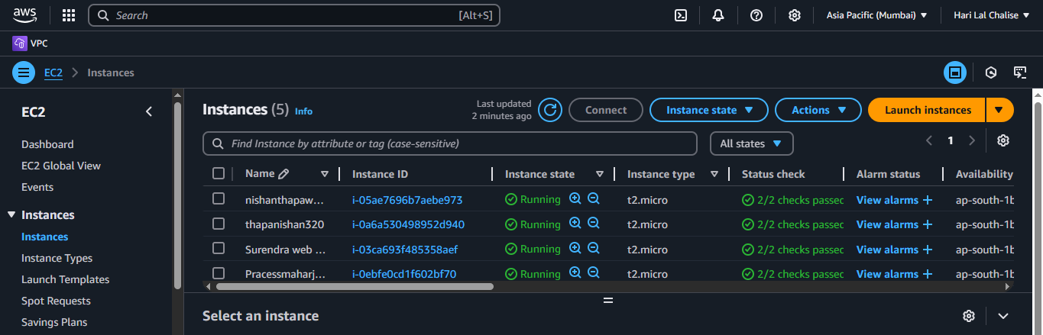

1. **Monitor your instance**

**Step 1:** Check on your instance and you will see details of that instance. It should look something like this.

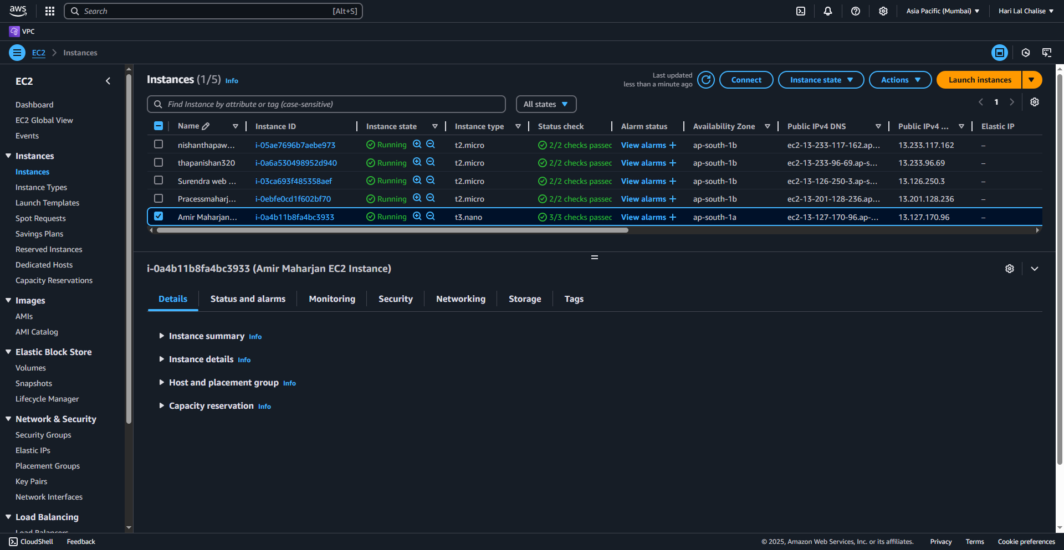

**Step 2:** There are a couple of tabs we should focus on like “Status and alarms” and “Monitoring”. In “Status and alarms” make sure that “System status checks” and “Instance status checks” have passed.

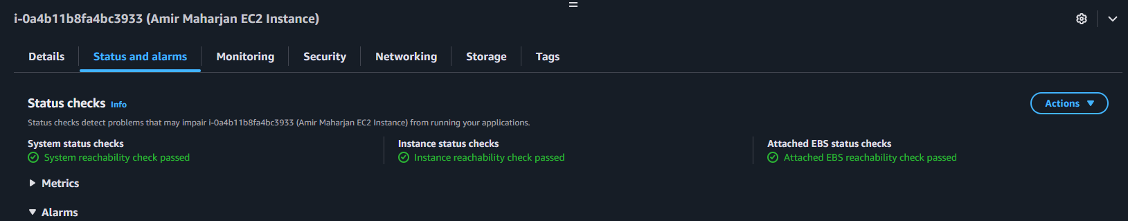

**Step 3:** In “Monitoring” tab, you can view details like cpu utilization, network in, network out, etc.

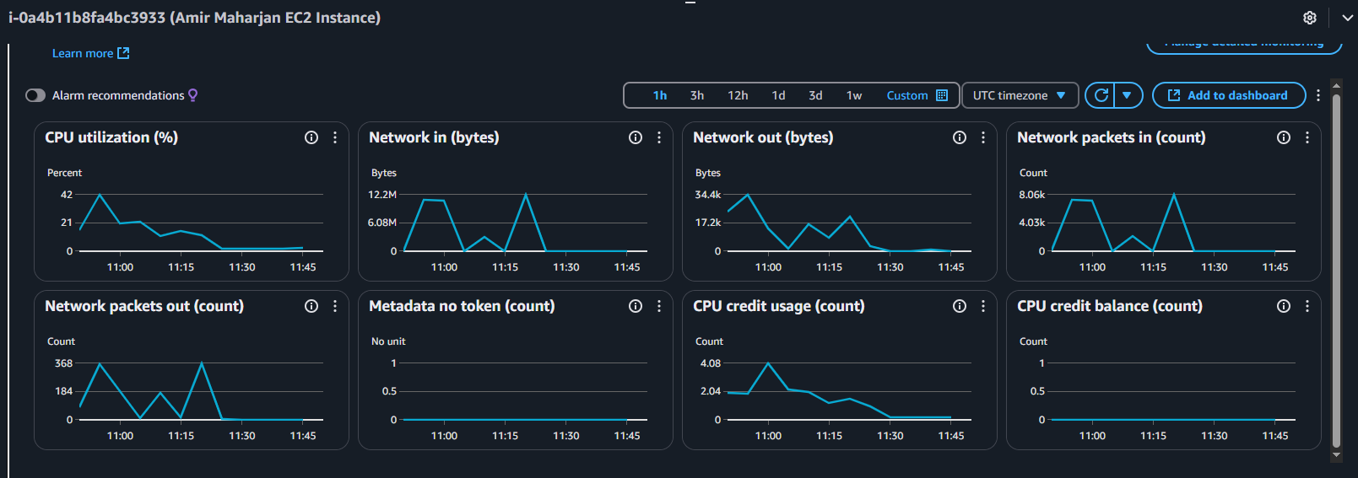

**Step 4:** To take screenshot of instance, click on the actions tab, a dropdown will be show, click on “Monitor and troubleshoot”, another dropdown will show and click on “Get instance screenshot”.

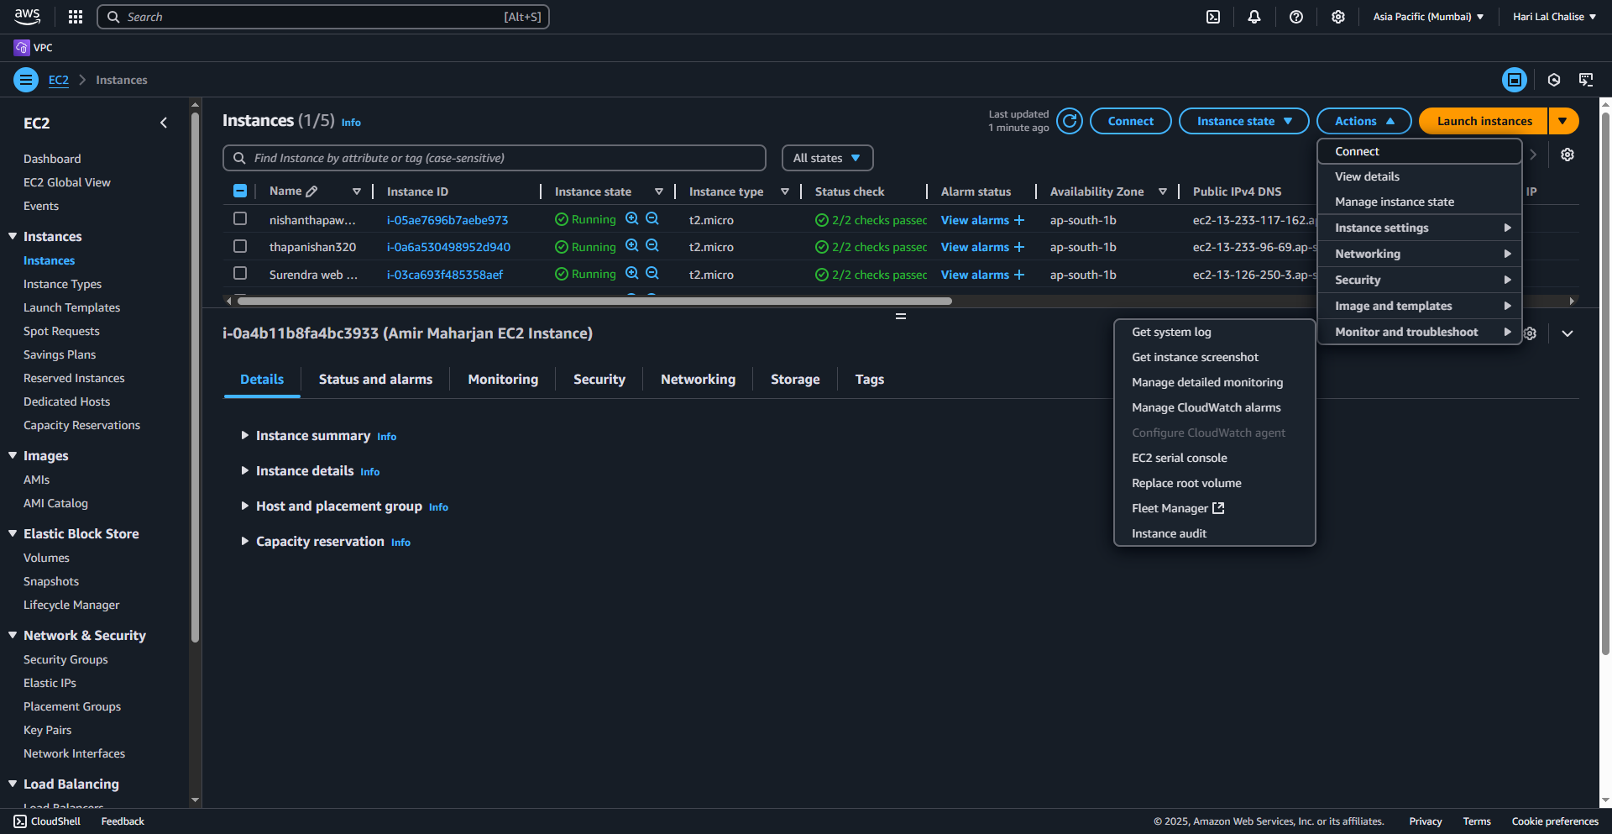

**Step 5:** You will be redirected to a page similar to below.

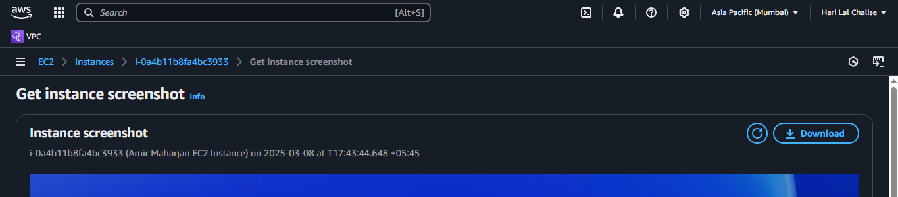

**Step 6:** You can also view the system log. Similar to taking an instance screenshot.

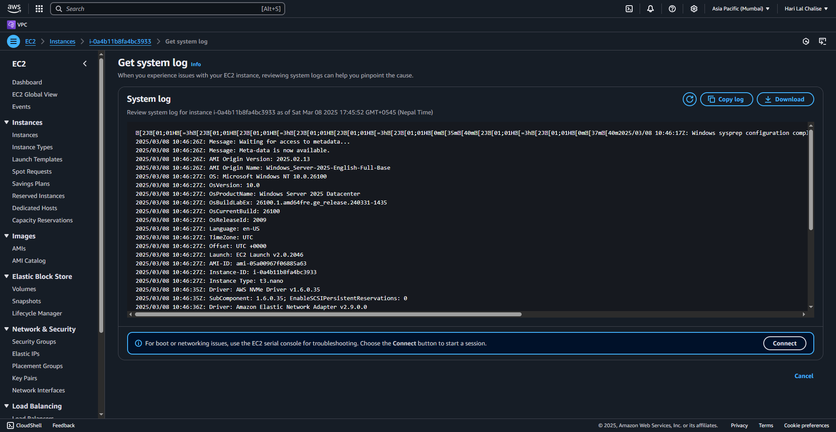

# Question 6

Creating a Virtual Private Cloud (VPC)

a. Explore the default VPC configuration

b. Explore a default Subnet

c. Create a custom VPC

d. Deploy an EC2 instance into your custom VPC

**Objective:** To explore VPC configuration, default subnets, create a custom VPC and deploy an EC2 instance into a custom VPC.

**Virtual Private Cloud (VPC):** a secure, isolated private cloud hosted within a public cloud.

**Usage:**

* **Network Isolation**: Create isolated networks for AWS resources.
* **Security**: Control inbound and outbound traffic with security groups and network ACLs.
* **Private Subnets**: Run private resources like databases or application servers in isolated subnets.

On the console dashboard, there is a search field. Search for “VPC”. One of the search results will be VPC service. Click on it and it will lead you to VPC dashboard.

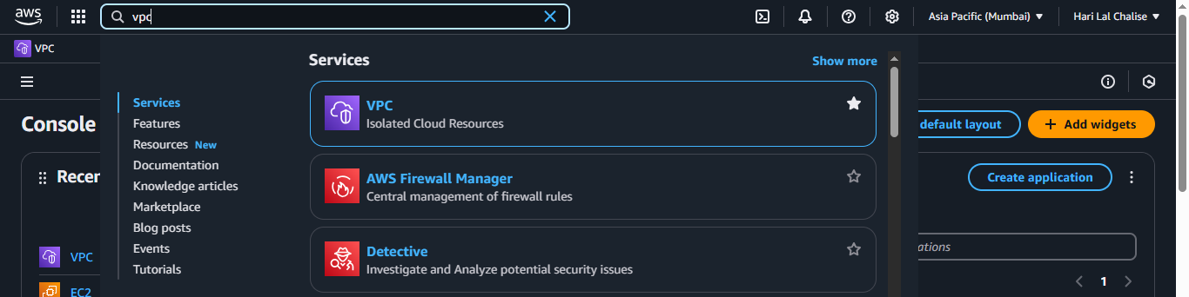

The VPC dashboard will look something like this.

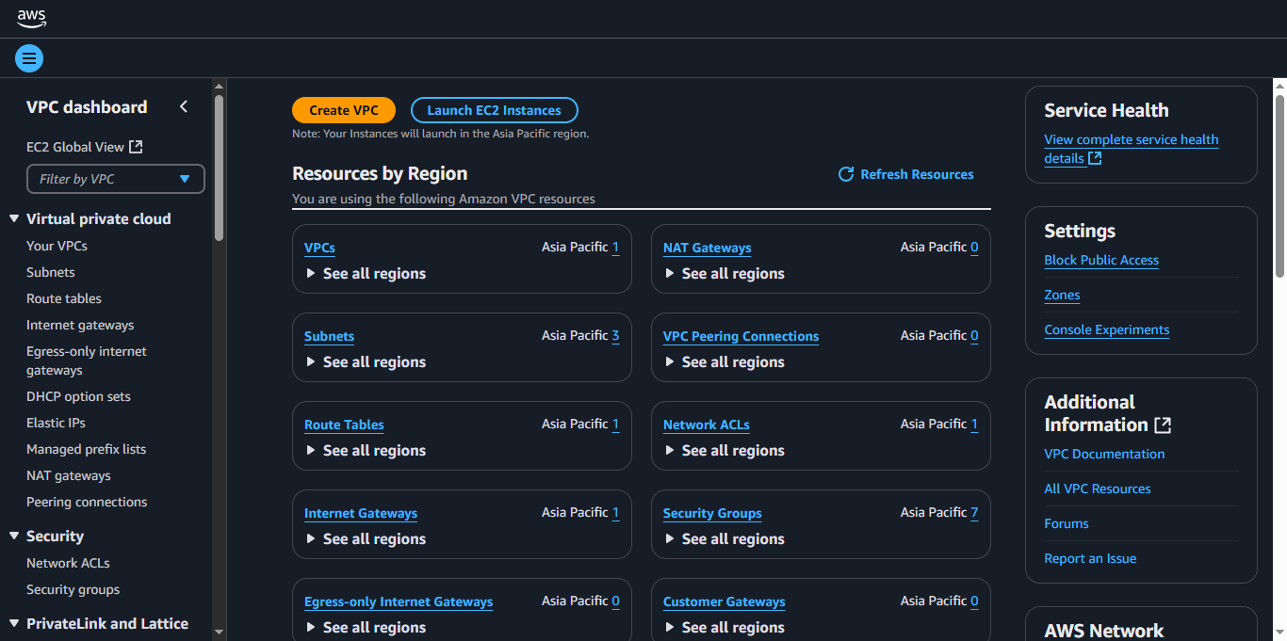

**1. Explore the default VPC Configuration**

**Step 1:** On the left-hand side, there is an option known as “Virtual Private Cloud”. One of its options is “Your VPCs” click on it and you will see default VPCs.

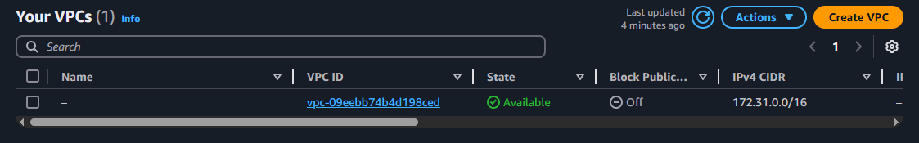

**Step 2:** To view default configuration of the default VPC, check the default VPC.

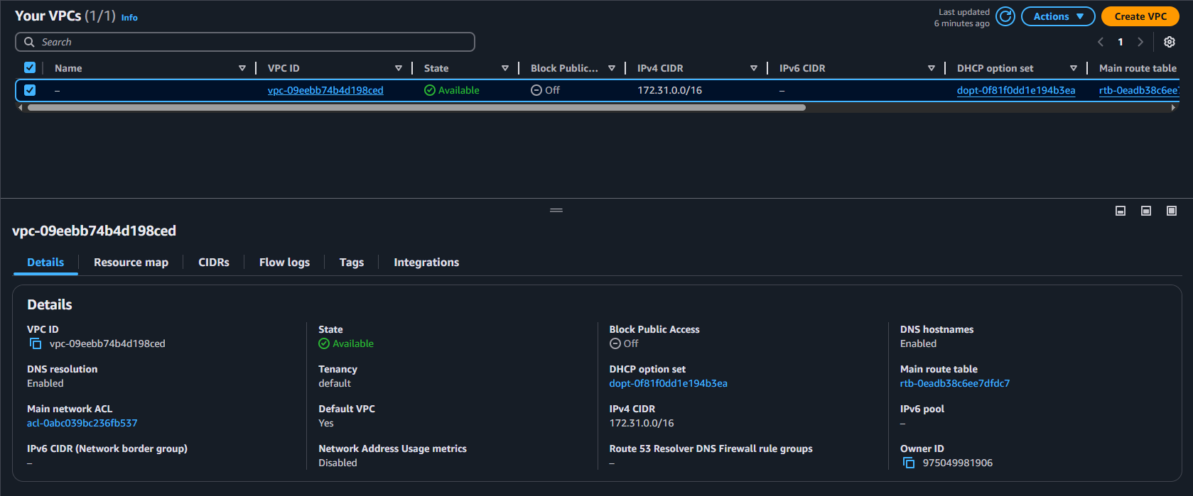

**Step 3:** There are multiple tabs like “Details”, “Resource Map”, “CIDRs”, etc.

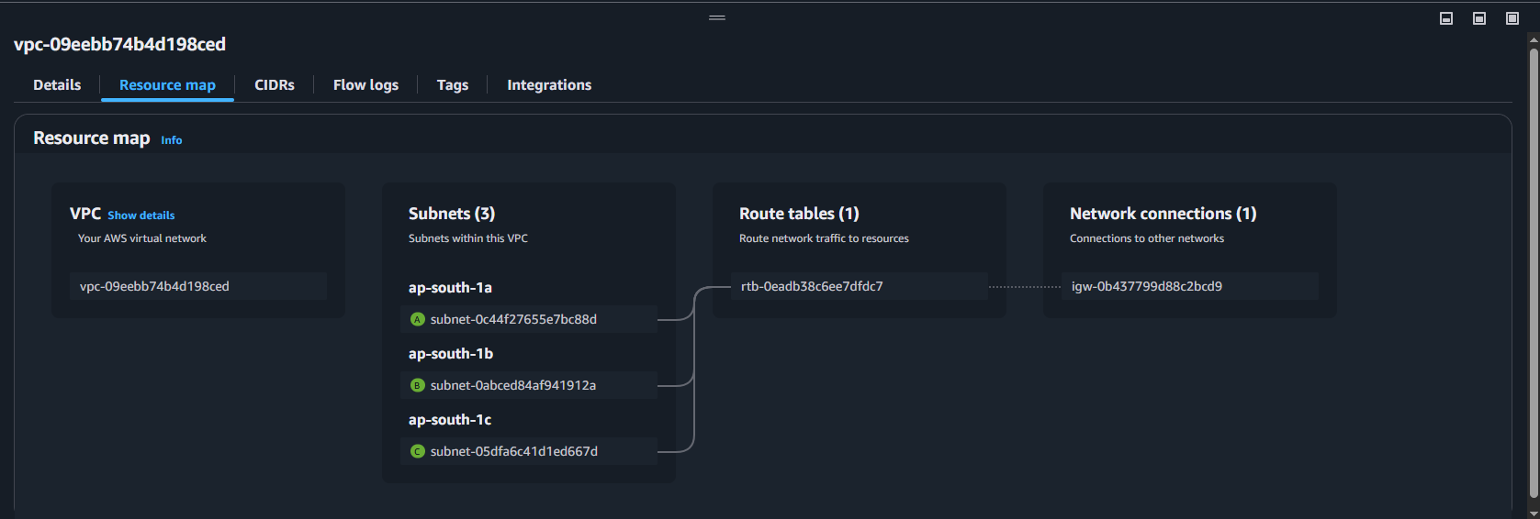

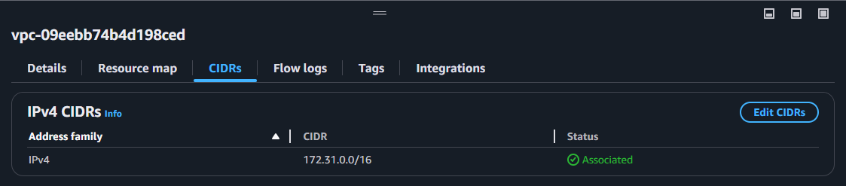

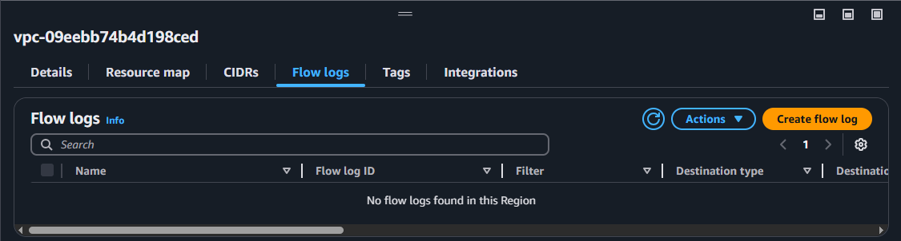

**2. Explore a default subnet.**

**Step 1:** On the left-hand side, there is an option known as “Virtual Private Cloud”. One of its options is “Subnets” click on it and you will see 3 default subnets.

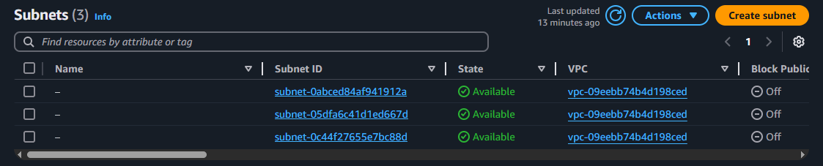

**Step 2:** To view default configuration of the subnets, check the one of the subnets.

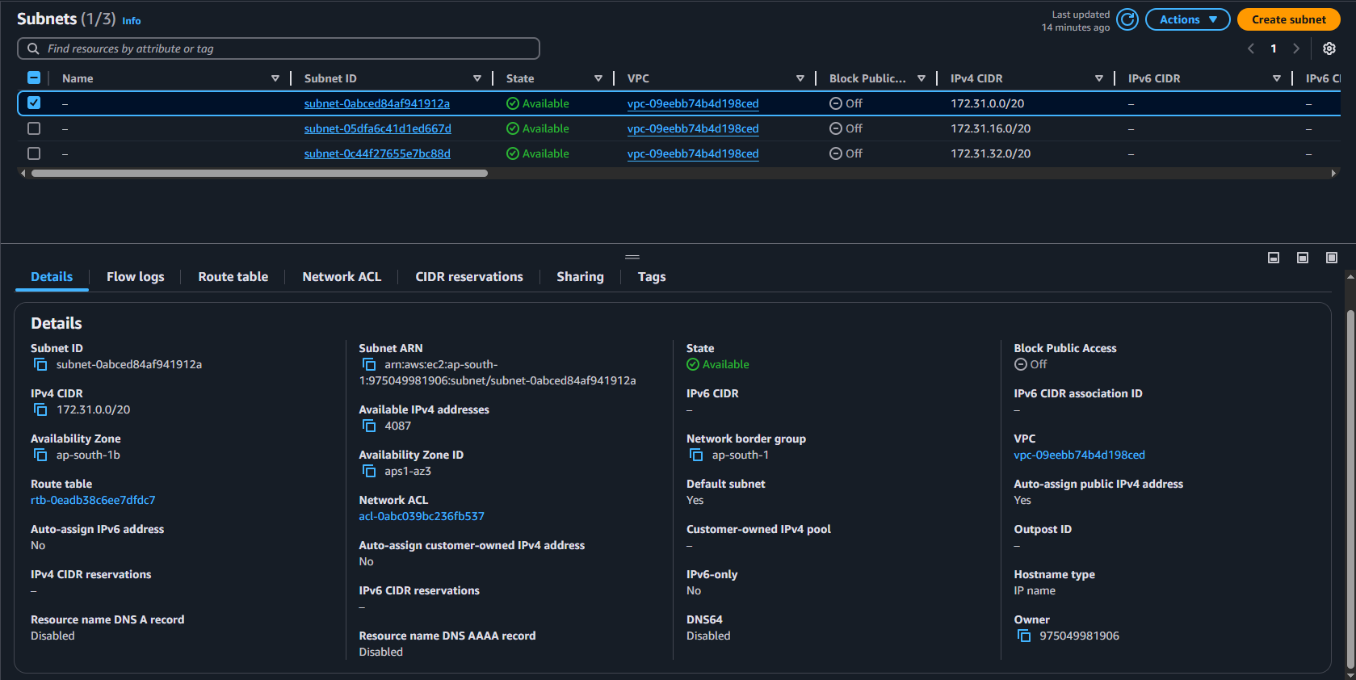

**Step 3:** There are multiple tabs like “Details”, “Flow logs”, “Route table”, “Network ACL”etc.

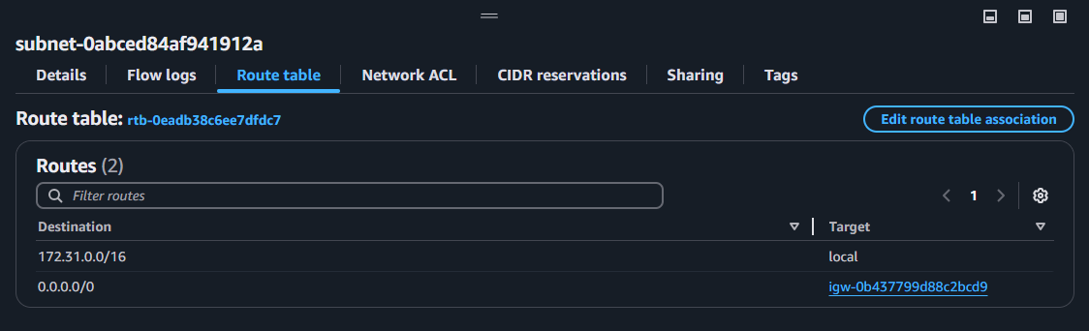

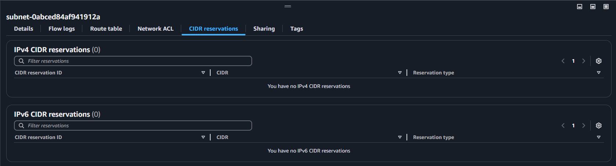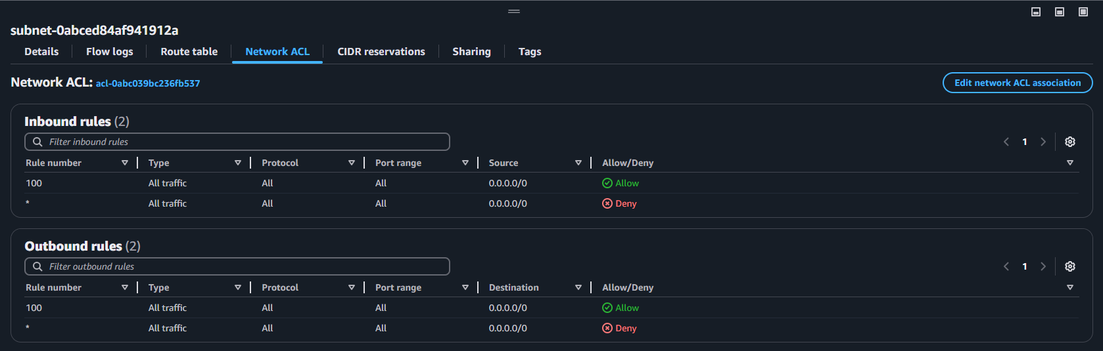

**3. Create a custom VPC.**

**Step 1:** In “Your VPCs” tab inside “Virtual Private Cloud”, click “Create VPC” button.

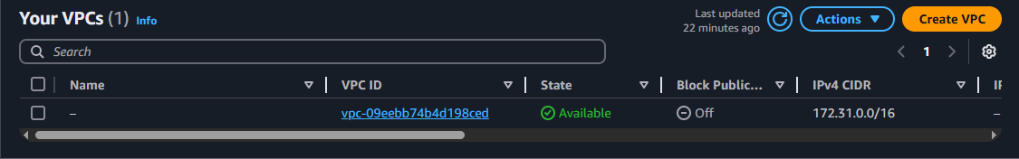

**Step 2:** After clicking the button, you should see an interface like below.

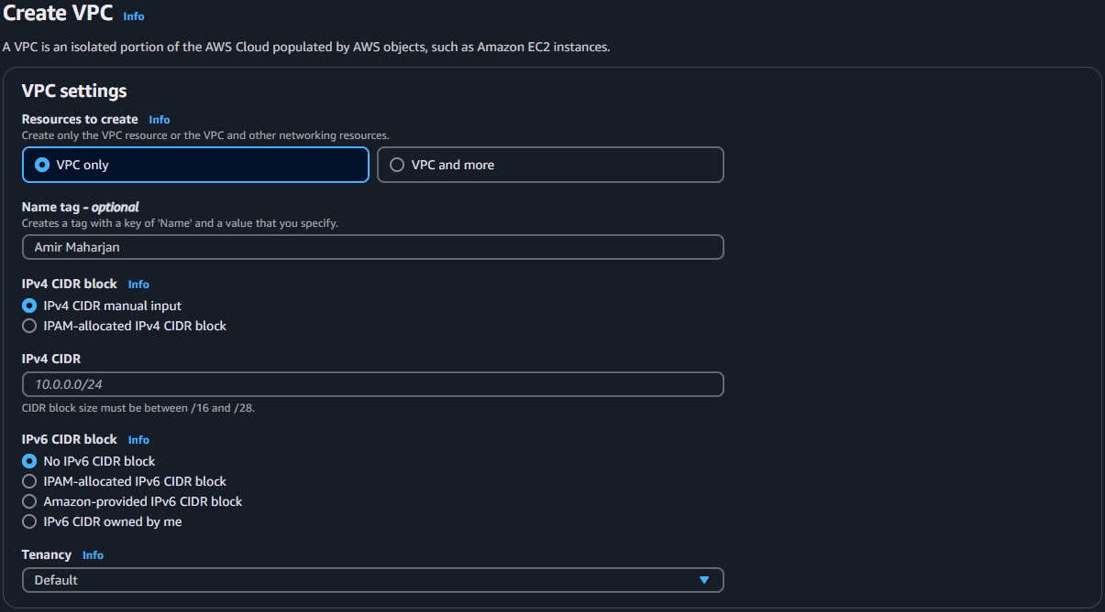

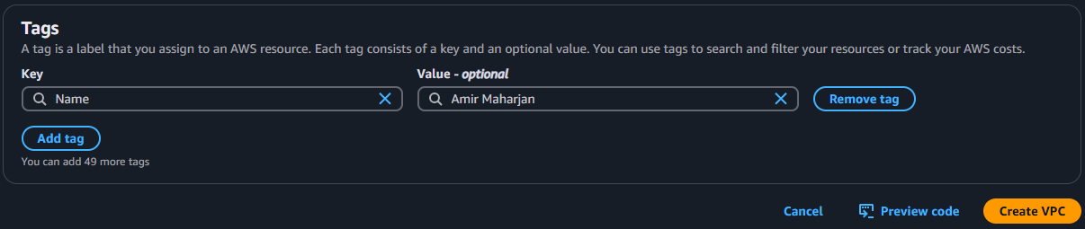

**Step 3:** After clicking “Create VPC”, you will see a success message.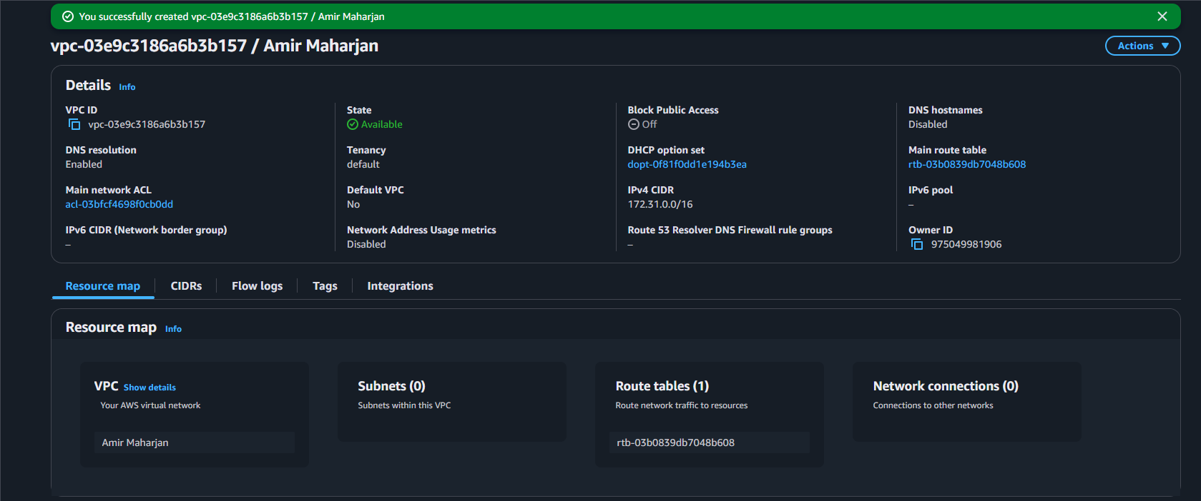

**Step 4:** You can view all your custom VPCs from “Your VPCs” tab and you can view its details the same way you viewed details of default VPC.

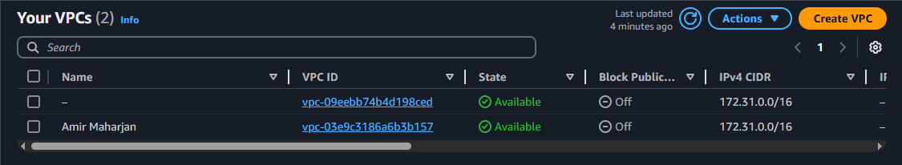

**4. Deploy an EC2 instance into your custom VPC.**

**Step 1:** Create an EC2 instance. Follow the steps we followed in Question 5 except one key difference, the selection of our custom VPC.

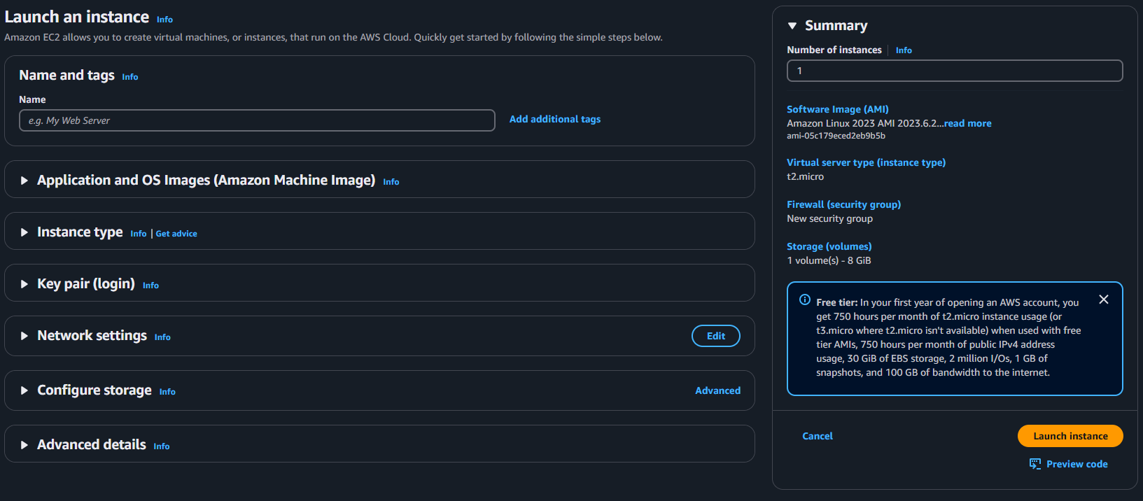

**Step 2:** In the “Network Settings” tab, click the “Edit” button. We can see a VPC field. Select our custom VPC and Subnet.

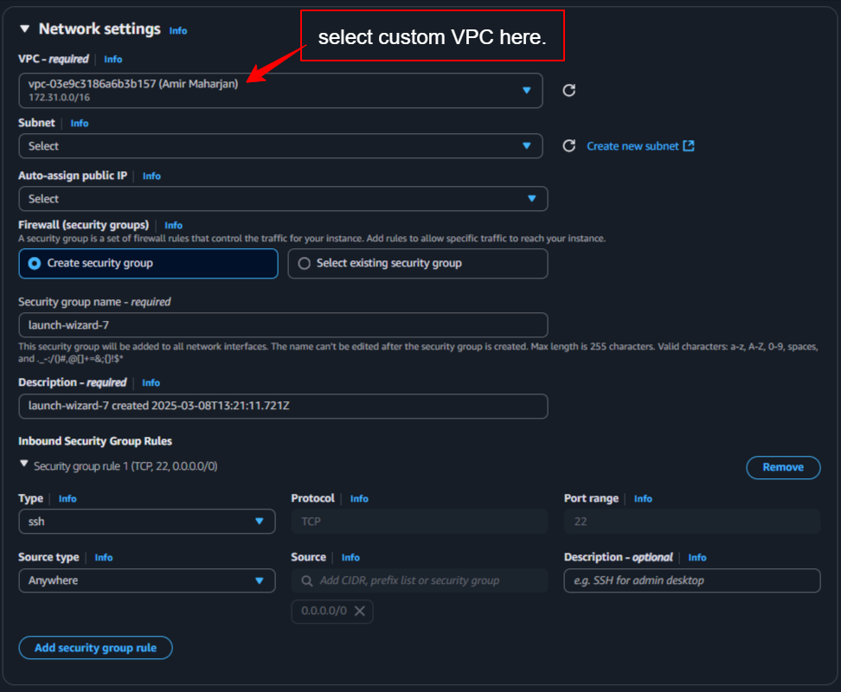

**Step 3:** Click the “Launch Instance” button and click “View all instances”, it will direct us here.

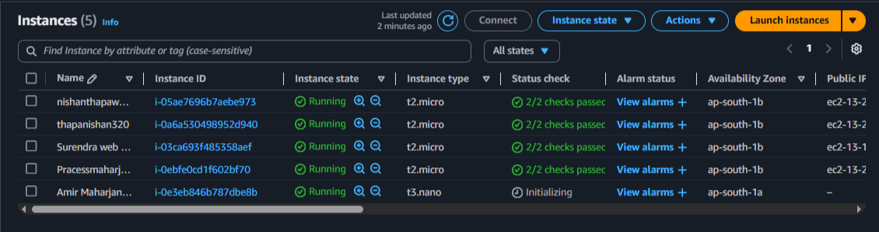

**Step 4:** Select our custom EC2 to view its details. As we can see our custom VPC and subnet is select as we desired.

